Purpose
The purpose of this policy is to establish a standardized methodology for measuring and reporting On Time In Full (OTIF) performance across the organization. The revised OTIF metric provides a consistent, accurate, and transparent view of customer delivery performance by defining the eligible order population, common data sources, calculation rules, reporting requirements, and accountability standards.
OTIF is the official company indicator for evaluating order fulfillment execution. It supports continuous improvement, customer service performance management, and data-driven decision-making across Supply Chain, Operations, Customer Service, and Commercial functions.

Scope
This policy applies to Companies 00010, 00020, 00030, 00034, and 00035 and covers both external sales orders and intercompany orders included in the OTIF measurement process.
Population | Order Types | Description
External sales | S4, SZ, SA | Customer sales orders, EDI external sales orders, and sample orders.
Intercompany | S5, SL | Intercompany sales orders, including MAP-to-India SL orders.

The policy establishes the standard methodology for calculating, reporting, and governing OTIF performance across all applicable entities and order types within the organization.

Summary of Policy

This policy defines the standard methodology for calculating and reporting the Company's OTIF performance. OTIF is measured at order-line level and evaluates whether customer orders are shipped in full and on time against the committed delivery date.

The policy defines:
- The population of orders included in the OTIF calculation.
- The criteria used to determine On Time and In Full performance.
- The rules governing OTIF code assignment, correction, and maintenance.
- The data sources used for official OTIF reporting.
- The reporting views available to assess performance by order, line, reason, department, and days moved.
- The roles and responsibilities for maintaining OTIF data integrity and performance reporting.

The OTIF metric described in this policy is the Company's official measure of customer delivery performance. Any exception to the methodology, order population, or reporting logic must be approved by Supply Chain leadership.

Sales Order population

The OTIF order population is based on EDW data and uses shipped sales detail records as the measurement base.

Selection rule | Requirement | Purpose
GL Date | On or after January 1, 2024 (GL Date >= 2024-01-01) | Establish the starting population for the revamped metric.
Record Type | Not equal to GL Detail (blank Record Type retained) | Include sales detail records only; drops GL-only summary rows.
Line Type | S | Include sales lines only.
Order Type | Not equal to ST | Exclude stock transfer order type from the report population.
Actual Ship Date | Populated with a real ship date (on or after 2000-01-01) | Measure only orders that have actually shipped; excludes the JDE 1900-01-01 empty-date placeholder.

Data integrity principle: Orders without an actual ship date are excluded from the shipped population. This keeps the metric aligned with shipped performance and avoids inflating the denominator with unshipped records.

Ship as Promised Calculation Methodology

Shipped as Promised — Order Level
The order-level view measures whether each order header was shipped as promised. If any line on the order has one or more promised-date revisions carrying an OTIF-relevant reason code, the entire order is treated as late.

Formula | (Orders in scope – Late orders) / Orders in scope
Orders in scope | Distinct order numbers included in the shipped population.
Late orders | Orders where at least one line has a promised-date revision carrying an OTIF-relevant reason code.

Shipped as Promised — Line Level

Formula | (Order lines in scope – Late order lines) / Order lines in scope
Order lines in scope | All shipped order lines included in the report population.
Late order lines | Order lines that have at least one promised-date revision carrying an OTIF-relevant reason code.

Counting logic: OTIF-relevance is determined by the Reason Codes reference (the single source of truth for which revision reason codes count as an OTIF miss). A line with no OTIF-relevant revision is treated as on time. A line with one OTIF-relevant reason code is counted as one late line, even if that reason recurs across multiple revisions. If a line has multiple different reasons, each reason may appear in reason analysis while the line still counts as one late line.

Report Explanation
All reports listed below use the same set of filters. Below is a brief explanation.
Filter | Use
Company | Filter by Company 00010 Americas, 00020 EMEA, 00030 MAP, 00034 China, or 00035 India.
Order Type | Filter by S4, S5, SA, SL, or SZ.
Segmentation | Filter by customer segmentation: Platinum, Gold, Silver, Bronze, Toll, Blank, or Inactive.
BU Revenue | Use BU Revenue ending in 00 to view intercompany orders only. Use BU Revenue not ending in 00 to view external orders only.
Reason | Exclude or isolate specific OTIF-relevant reason codes for scenario analysis.
Sold-to Name | Filter to a specific customer.
Date Range | Select the desired reporting window.

Shipped As Promised % (Orders)
This page provides the Shipped As Promised metric at order-header level. It shows performance for all customers and split views for Strategic customers and standard customer segments.
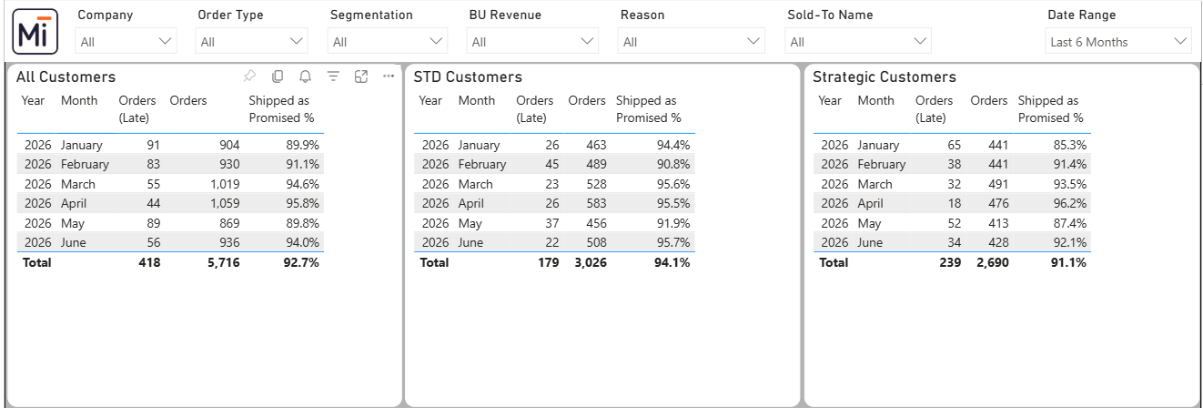

Shipped As Promised % (Lines)
This page mirrors the order-level view but calculates performance at order-line level. This is the preferred view for operational discussions because it reflects performance at the line execution level.
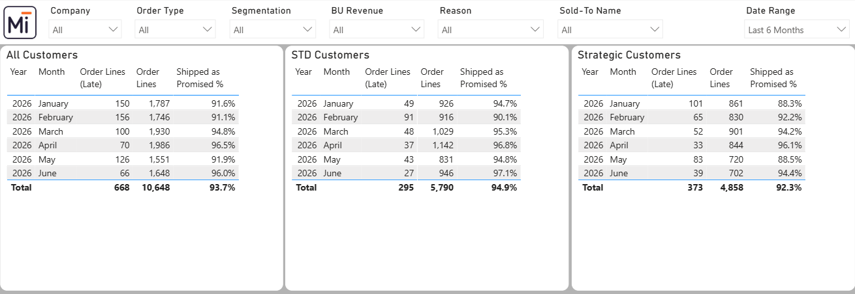

OTIF by Reason
This page provides a detailed view of OTIF misses by reason code. It links late lines, revision reasons, order-line comments, and the revision log to support root-cause analysis.

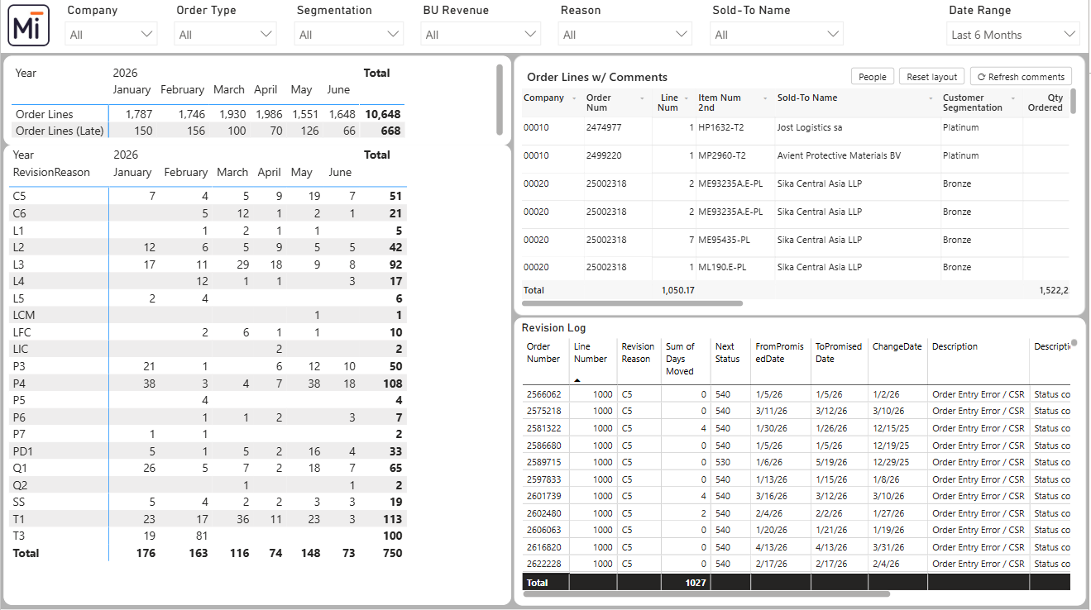
Important: OTIF hits by reason may be higher than the number of late lines because one late line can be affected by multiple different reason codes. For example, a line affected by both an L3 raw material delay and a T1 logistics delay counts as one late line but two reason hits in reason analysis.
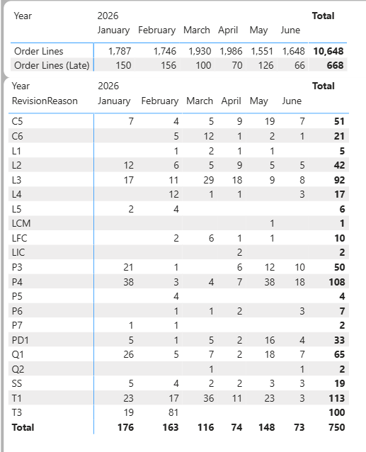
OTIF by Reason summary table.
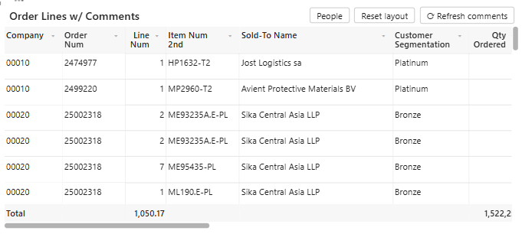
Order Lines with comments.
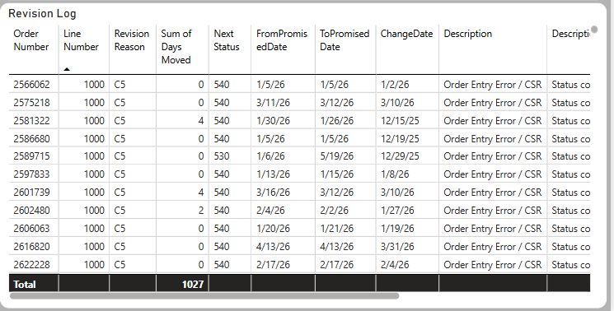
Revision log detail.

OTIF by Days moved
This page shows OTIF misses and the related days moved, enabling both frequency and impact assessment by reason code.
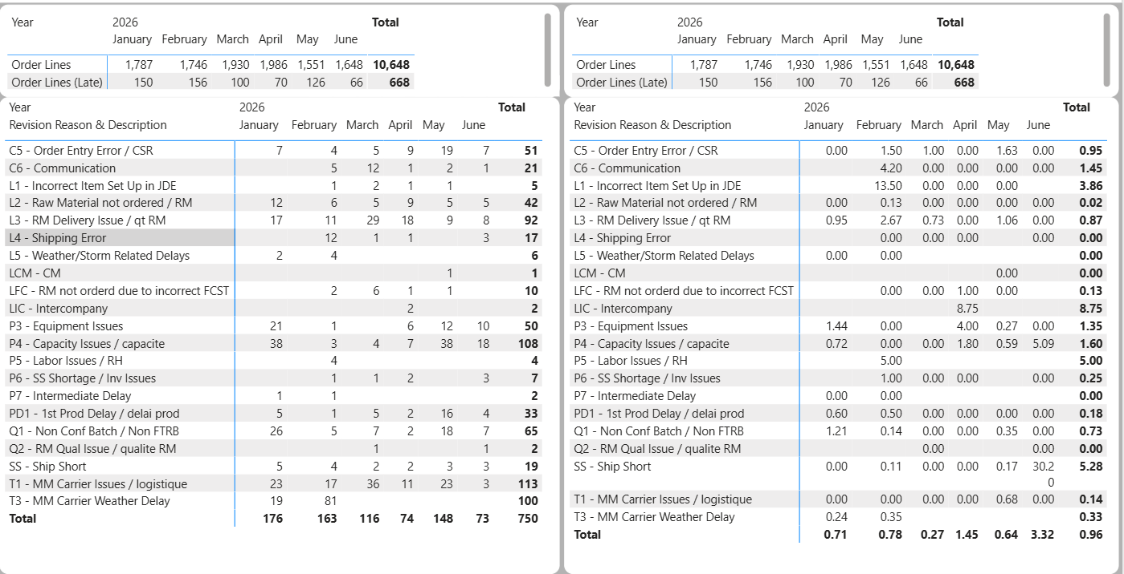

OTIF by Department
This page summarizes ownership of OTIF misses by department and displays both the number of OTIF hits and the days moved associated with each category.
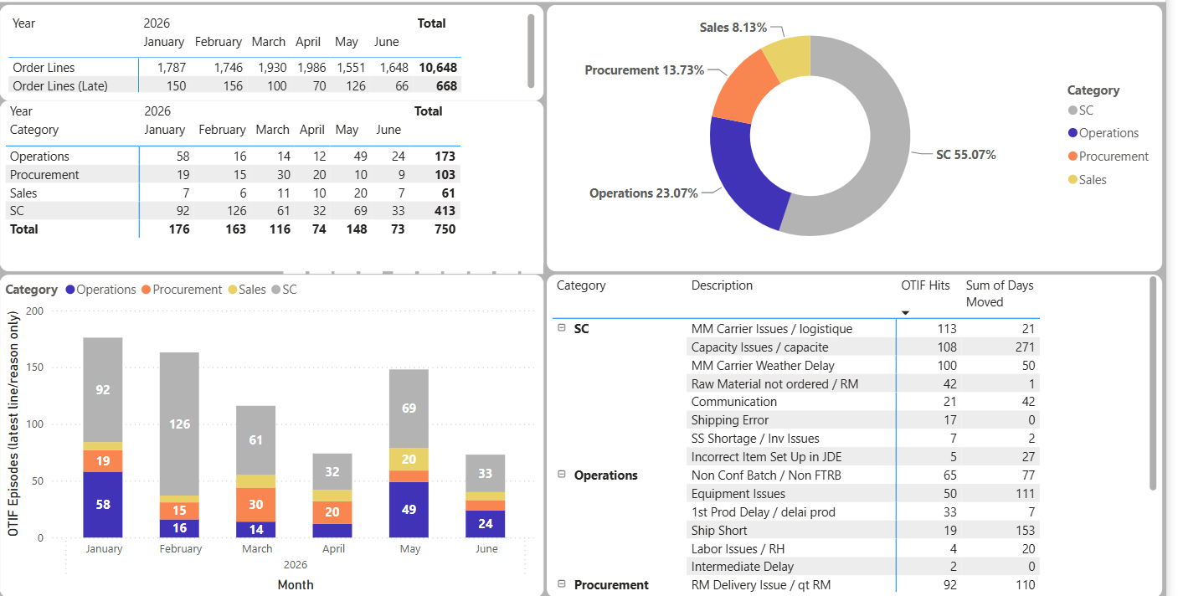

OTIF Analysis and Pareto views
The OTIF Analysis page provides detailed transactional data that can be exported for additional analysis. The Pareto views prioritize the most material OTIF reasons either by count of hits or by days moved.
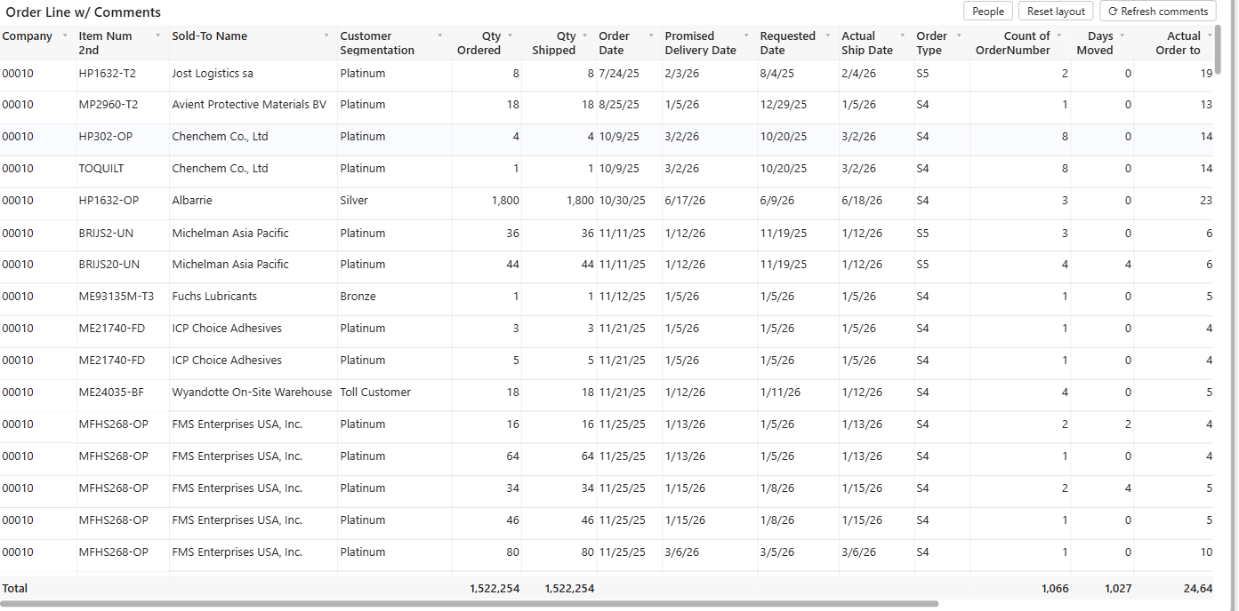
OTIF Analysis extract view.
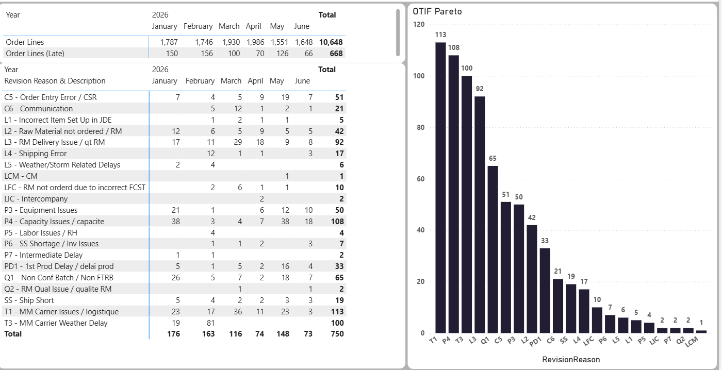
Pareto by OTIF hits.
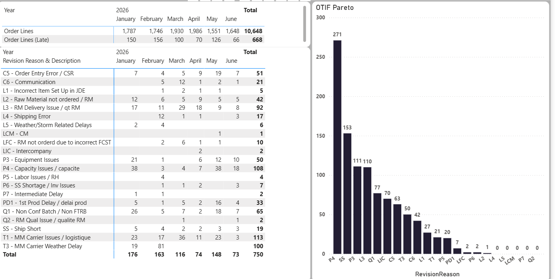
Pareto by days moved.
OTIF Maintenance
The OTIF Maintenance page supports centralized correction and contextualization of OTIF reason data. Any user with report access can correct reason codes and enter comments directly in the tool, reducing the need for separate offline trackers.

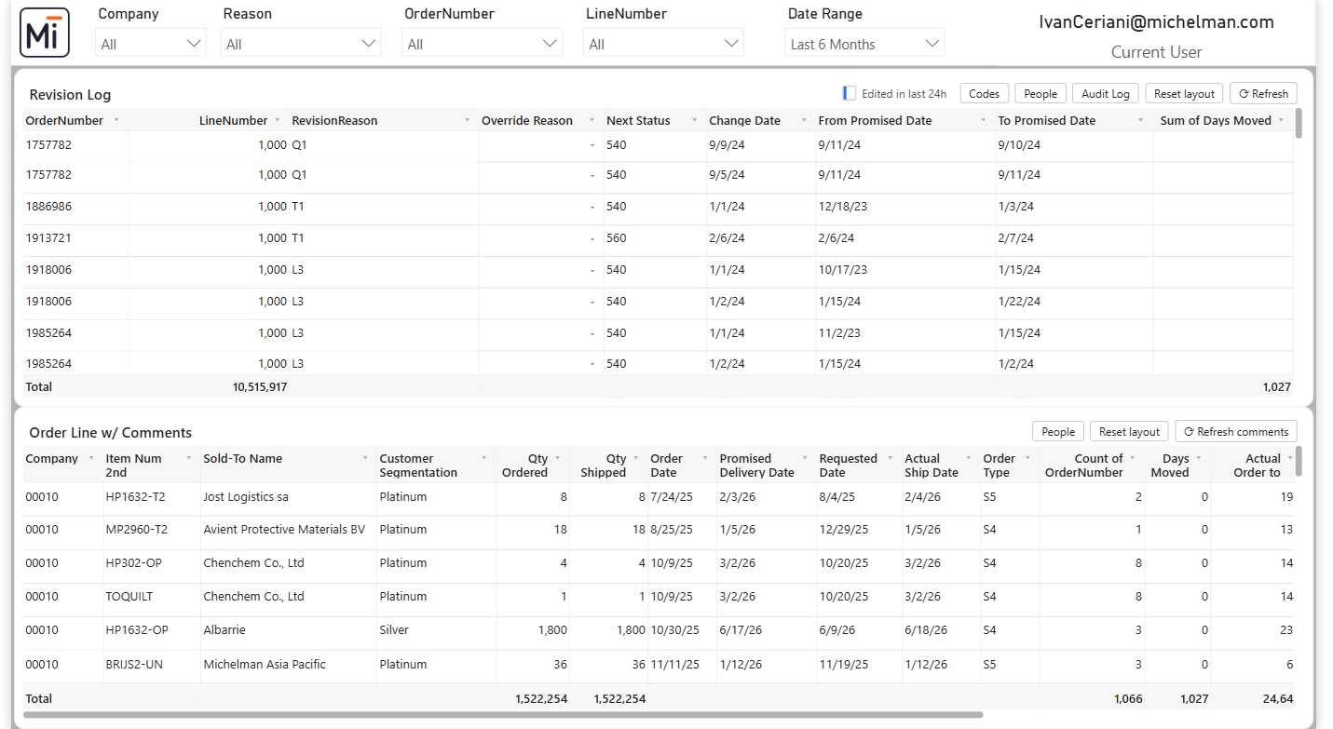

Reason correction
If an incorrect reason was assigned, enter the correct value in the Override Reason field. The override reason replaces the previous reason in the metric logic and is reflected in the OTIF metrics after the next report refresh. The originally reported reason is always retained so that as-reported performance can still be compared.
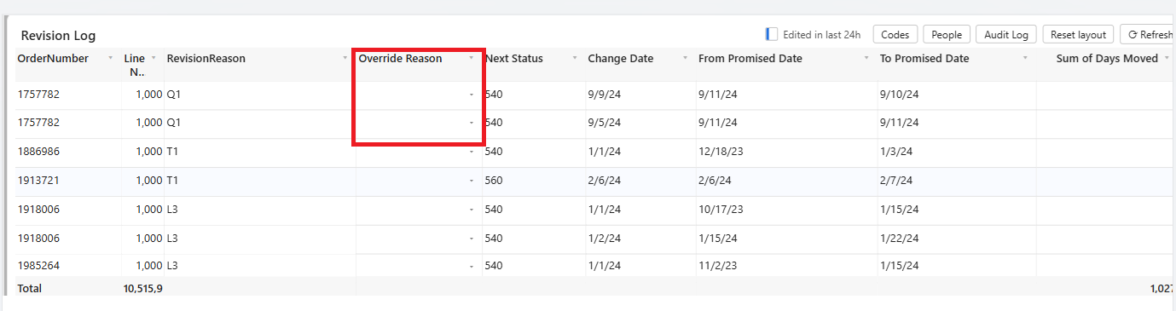
Order-line comments
Comments may be entered at order-line level to provide additional context for the OTIF hit. Comments should be factual, concise, and business-relevant.
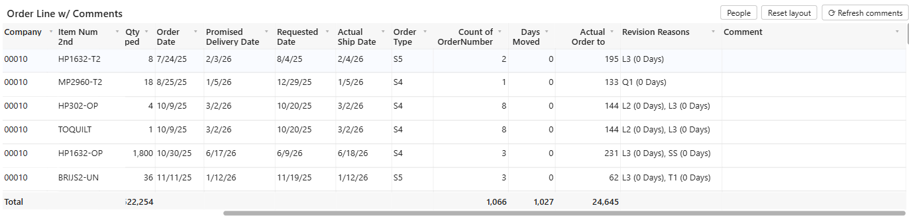

Roles and Responsibilities

Role / Function | Responsibility | Expected outcome
Global Supply Chain | Own the OTIF methodology, governance, and policy maintenance. | Consistent global measurement standard.
Customer Service | Ensure order data and customer-facing order updates are accurate. | Reliable order-level data and customer context.
Planning / Operations / Logistics | Review OTIF misses, validate root causes, and support corrective actions. | Accurate reason assignment and action-oriented performance reviews.
Report Owner / BI Support | Maintain the report logic, refresh process, and data integrity checks. | Stable, trusted, and auditable reporting output.
Business Users | Use the official report and avoid local metric variations unless approved. | Single source of truth for customer delivery performance.

Governance and Exception Handling
The official OTIF metric must be reported from the approved OTIF Power BI report and its defined EDW data population.
Changes to calculation logic, report filters, reason-code treatment, or order inclusion rules require review and approval by Regional Supply Chain leadership.
Reason-code corrections should be made in the OTIF Maintenance page using the override functionality rather than by maintaining separate offline files.
Any known data issue affecting reported performance should be documented and communicated with the report owner before the metric is used for formal performance review.
Historical performance should not be restated unless a governance-approved correction has been applied to the underlying data or report logic.

References
Teams — Manufacturing Operations > Documents > Policies > Policy – Global Sales Order Management Process Flow.

Definitions
Term | Definition
OTIF | On Time In Full; company metric used to measure customer delivery performance.
EDW | Enterprise Data Warehouse; source population used for the official OTIF report.
Order in scope | An order included in the OTIF population based on the defined company, order type, line type, record type, GL date, and actual ship date criteria.
Late order / late line | An order or order line with one or more promised-date revisions carrying an OTIF-relevant reason code.
OTIF-relevant reason | A promised-date revision reason code flagged as OTIF-relevant in the Reason Codes reference (the single source of truth). Reason codes originate in the promised-date revision ledger, not on a static order-line field.
Days moved | Net number of days the promised delivery date moved across the OTIF-relevant revisions captured in the revision ledger.
Override reason | Correction entered in the OTIF Maintenance page to replace an incorrectly assigned reason.

Document Control
Policy owner | Global Supply Chain
Document owner | Ivan Ceriani
Review frequency | To be confirmed
Approval authority | Supply Chain leadership
Storage location | To be confirmed

Approval and Revision History
Revision Number | Content / Reason | Date | Revision Owner
0 | Initial release | April 15, 2025 | Ivan Ceriani
1 | Policy wording enhanced and report usage guidance consolidated | July 7, 2026 | Ivan Ceriani

